Immediate Window
Immediate window is very much common and a favorite with all developers. It's very much helpful in debug mode of the application if you want to change the variable values or execute some statement without impacting your current debugging steps. You can open the Immediate window from menu Debug > Window > Immediate Window { Ctrl + D, I / Alt + Ctrl - I }. Immediate window has a set of commands which can be executed any time during debugging. It also supports Intellisense. During Debug mode, you can execute any command or execute any code statement from here.
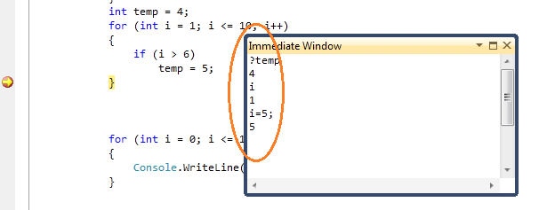
Figure: Basic Immediate Window

Note:- “Immediate Window” is in sync with Autos and Locals windows.

